Context
In a biodiversity-monitoring mobile app, users enter field observation data while working outdoors.
A transect is a sampling route consisting of multiple ordered geographic points. It belongs to a monitoring site.
Ecologists walk along transects while recording occurrences of individual birds, beetles, or other species.

Initial requirement
A logged-in user is viewing a map screen. Existing transects may be visible on the map. The user should be able to create a new transect from this screen.

Your task
Refine this initial product requirement so that it is ready for implementation and QA. Do not write code or build a working prototype. The requirement intentionally leaves questions open: show us how you identify and handle them.
Please describe:
- the proposed user journey for creating a transect;
- questions you would ask product owners, domain experts, or engineers;
- assumptions you make where answers are unavailable;
- acceptance criteria that an engineer and QA tester could use;
- relevant validation rules, edge cases, and error states;
- tradeoffs or alternative approaches you considered.

Format
Use any format that helps communicate your proposal: annotated sketches, Figma screens, AI-generated wireframes, written UX descriptions, or a combination of these. Visual polish is not part of the assessment.

PREPARATION

Initial questions to the Product owner (and assumptions in italics)

0. Regarding the app availability:
- Is this a real time app or it accepts later entries? → It only works in real time, it needs a device connected to the internet with a GPS.

1. Regarding transects:
- Which parameters are documented for a transect? → creation_date, user_id, points.
- How many points could a transect have? Is there a minimum and maximum? → at least 2 points.
- How distant could each point be one from another? → they need to be at least 0,1km separated to register them as a different point.
- If the new point is too close to one from another transect, can the app use the nearest point as current location? → Yes, even when it is from the same transect, two different points should be at least 0,1km separated from each other.
- Can a new transect have points not so distant to an existing one? → No. The observation will be on the old transect if it exists.
- Can a new transect share points with another? Which percentage of points can be shared? → They can share less than 50% of the points, if not the entry will not be accepted.
- Can a new transect intersect existent one? → Yes.
- Is there a limit on how many transfer can a user create? → One user can add up to 5 transects per day.

2. Regarding observations:
- Which parameters are documented for an observation? → transect_id, datetime, lat, lng, species_code, species_number_observed.
- Is there a fixed list of available species to document? → Yes.
- Is the user expected to add new species to the list? Will this new species then be available for everybody else? → The user can’t add new species.
- In case it is, should this be approved by a third party first? → Doesn’t apply.
- How many categories should be observed in order to accept the new entry? → At least 1 species should be observed.
- Can an observation be modified after creation? → No
- What happens if connection is lost? Will it save the state and persist the observation later? → No

Assumption: If the user tries to create an observation on a point that is closer than 0,1km from another existing point, the observation will be created on the same exactly location the previous point is.

FIRST PROPOSAL

User Journey:
- User logs in to the app via username and 2fa.
- Current position is showed in the main screen map with a GPS symbol.
- User clicks on “+” > App displays “Add transect” screen.
- User completes the form:
  - Select species from dropdown list.
  - Select amount observed.
  - Optional: Enter a new observation.
  - Current GPS position, DateTime stamp and user_id are automatically generated.
  - Click Save or Discard.
  - User is shown a message and redirected to the home screen again
- If the user clicked Save, then a new point is generated into the main screen with a new color.
- When the user moves to another location, the map shows the new location joined with a single line and the user can add a new observation point by clicking the GPS symbol on the right side, which links to the form of step 4 again.
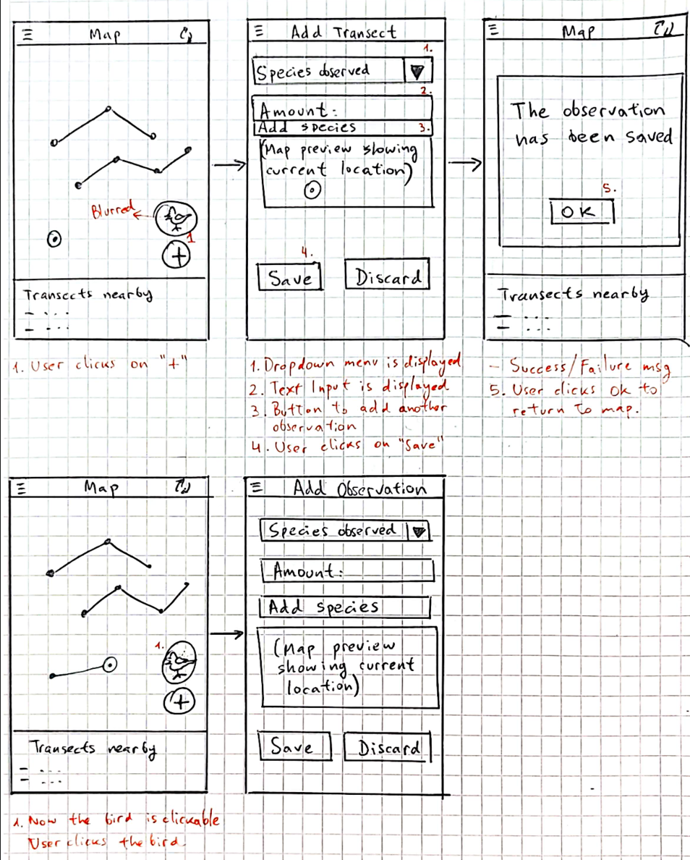

IMPROVED PROPOSAL

- Just display one “+” button on the map (instead of one for adding a transect and one for adding an observation): This button will serve as “Add observation” and the app will decide by itself if it is an observation from a new transect or this should be just one point from an existent one.

- The 0,1km limitation is too short for this. I should ask the experts if this could be extended. It would be nice to have a limit area within the new observations are part of existent transects in order to prevent the creation of lots of new ones.

- Add an option displayed on the Hamburger menu to accept later entries. It should give the flexibility to manually enter latitude and longitude and show a preview on the map where the user can then Save or Discard the observation. This option should add a calendar menu and a Time selector to save the entry. Then the app will decide if this is a new transact or the point is close to an existent one an use it instead.

QA CRITERIA

- Point validation: two points need to be at least xxx km to be considered different points, two points cannot share same coordinates, to persist a new transect there should be at least 2 points.
- Transect creation: The transects could be created both in real time or later.
- The app will need permission to access to mobile location, important to test this for every kind of device.

